Sanaa Gokeh

**Computational_Lab_3**

**Answer 1**

**Ab initio methods**

* Ab initio methods are difficult due to the increasing computational cost with the number of electrons.
* Ideal ab initio force fields require no fitted parameters.
* Ab initio force field methods are based on fragmentation approaches and intermolecular perturbation theory.
* High-level ab initio methods can attain results that are in reasonable agreement with experiments for small, isolated, molecular systems.
* Ab initio methods is often inhibited by the steep rise of the computational cost with respect to the system size.
* An ab initio force field refers to one that is derived from quantum mechanical first principles and does not contain any empirically fitted parameters.
* Ab initio force fields are generally computationally more expensive than classical force fields.

**Harmonic functions**

* The accurate potential energy surface of a chemical system is usually obtained by approximately solving the Schrödinger equation at many points in the coordinate space of the component atoms.
* Harmonic functions are typically used to describe bending and stretching.
* The non-bonding electrostatic and van der Waals contributions are often computed using a charge-charge Coulomb term and a Lennard-Jones potential.
* permits the modeling of very large systems of the order of tens of thousands of atoms, such as proteins, bulk liquids, and crystals.
* one feature that differentiates these force fields from ab initio force fields is treating the bonding interactions with a classical bonding model.
* Non-ab initio force fields have functional forms that do not contain empirically fitted parameters.
* The R term is based on a firm physical foundation, although the coefficient C is typically fitted to experiments.
* Classical force fields can produce results that are comparable with experiments.

Note:

” The distinction between an *ab initio* FF and a non-*ab initio* FF is not so clear-cut in practice since it is difficult to completely eliminate fitting in a force field.

Force fields with empirical parameters may not be reliable if the systems used in the parameterization process significantly differ from the system being investigated or if the data set used for parameterization is small”.

<https://aip.scitation.org/doi/10.1063/1.5009551>

**Answer 2**

The ab initio MD and centered MD simulation use are limited by long trajectories. Ab initio data are used in the parameter-model 3 (PM3) semiempirical Hamiltonian to investigate the reaction dynamics by propagating quasi-classical trajectories. The trajectory is calculated using the Hamiltonian.

The scalability issue of ab initio codes can be calculated by dividing algorithms to one-electron property evaluation, and energy evaluation.

**Computational_Lab_2**

**Harmonic Wavefunction**

1. What is the optimal value of E of phi in natural units? How does this value compare to the true ground state energy of the Harmonic Oscillator?

the optimal value of E of phi in natural units is 0.75 and it is less than the ground state energy of the harmonic oscillator. = 1.

1. What is the optimal value of alpha in natural units? How does phi of X with this value of alpha compare to the true ground state wavefunction?

optimal value of alpha in natural units is 1 atomic unit. phi of X with this value of alpha is the same as the true ground state wavefunction

1. What is the kinetic energy expectation value of the optimized trial wavefunction in natural units?

The kinetic energy expectation value of the optimized trial wavefunction in natural units = 0.175 atomic unit

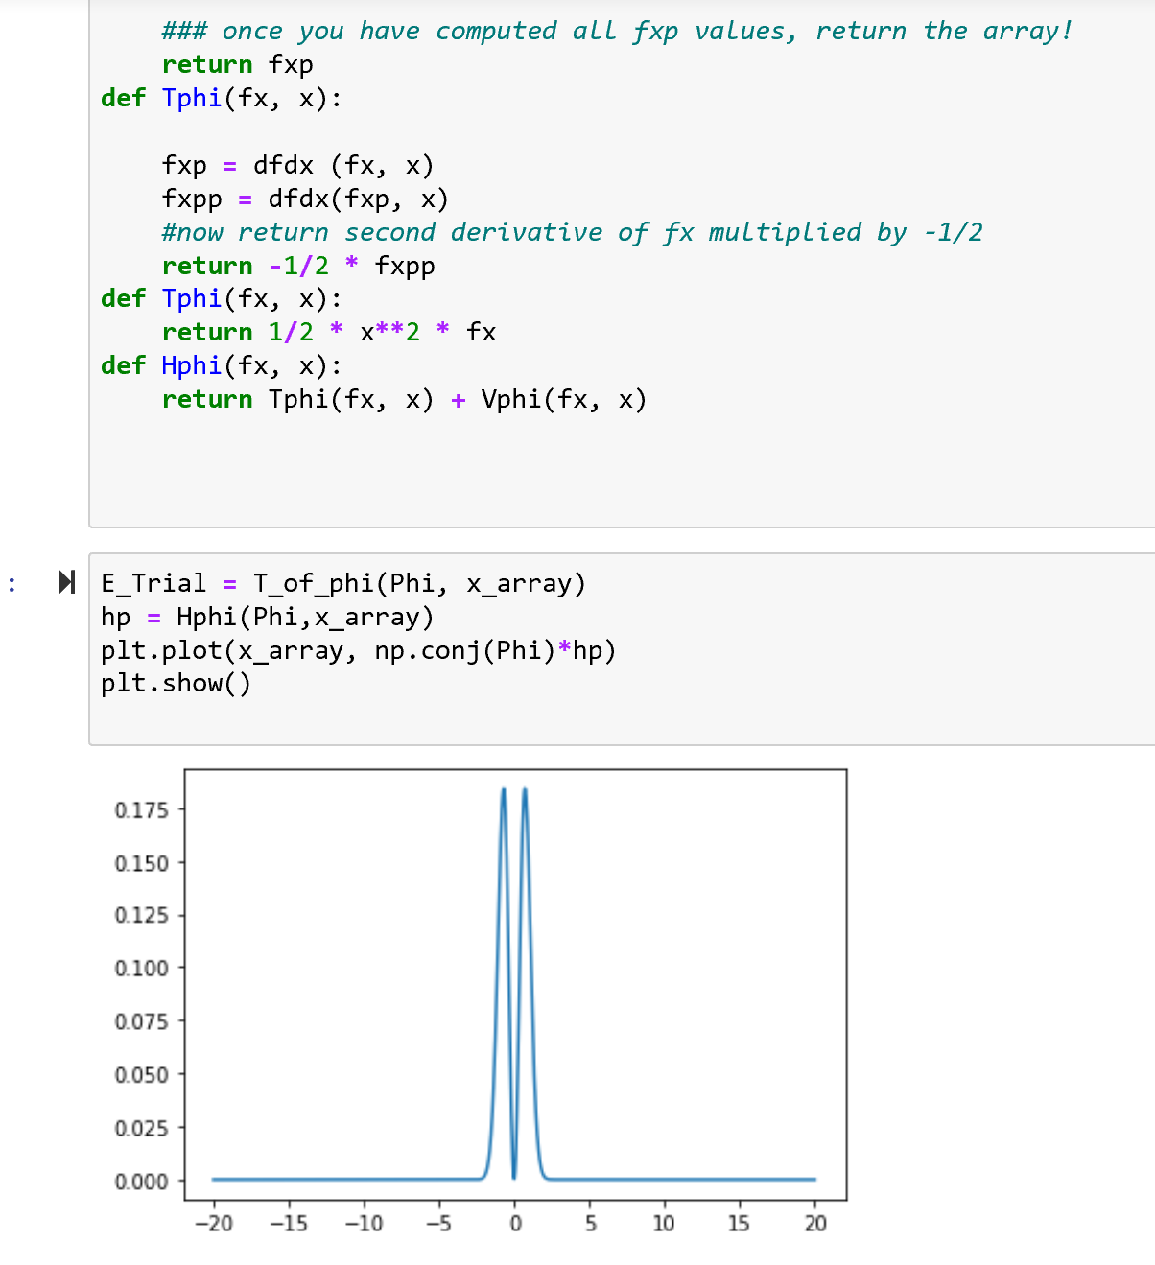

1. What is the potential energy expectation value of the optimized trial wavefunction in natural units?

The potential energy expectation value of the optimized trial wavefunction in natural units = 1 atomic unit

